PROJECT REPORT OF INDUSTRY ORIENTED HANDS ON EXPERIENCE (IOHE)
ON
AI-Based Detection of Spiritual Burnout Using Behavioral Pattern Analysis
submitted in partial fulfilment of the requirements for the award of degree of

BACHELOR OF ENGINEERING
In
COMPUTER SCIENCE AND ENGINEERING

Submitted by: Supervised By:
Shivansh Jaiswal Dr. Preeti Saini
2210992323 Assistant Professor, CUIET
Chitkara University, Rajpura


DEPARTMENT OF COMPUTER SCIENCE AND ENGINEERING

CHITKARA UNIVERSITY INSTITUTE OF ENGINEERING AND TECHNOLOGY
CHITKARA UNIVERSITY, PUNJAB, INDIA

CONTENTS

S.No. | Title | Page No.
 | Acknowledgement | 4
 | List of Figures and Tables | 5
 | Abstract | 6
1 | Introduction | 7
2 | Methodology | 7
3 | Tools and Technologies | 11
4 | Implementation | 11
5 | Major Findings/Outcomes/Output/Results | 11
6 | Conclusion and Future Scope | 14
7 | References | 15
8 | Appendices | 16

DECLARATION

I hereby certify that the work which is being presented in the project report entitled “AI-Based Detection of Spiritual Burnout Using Behavioral Pattern Analysis” in partial fulfilment of requirement for the award of the degree of Bachelor of Engineering (Computer Science and Engineering) submitted in the department of Computer Science and Engineering at Chitkara University Institute of Engineering and Technology, Chitkara University, Punjab, India, is an authentic record of my own work carried out under the supervision of Dr. Preeti Saini. The matter presented in this project report has not been submitted in any other university/institute for the award of any degree.

Place: Rajpura (Shivansh Jaiswal)
Date: 14.05.2026 (University Roll No. 2210992323)

This is to certify that the above statement made by the candidate is correct to the best of my knowledge and belief.

Dr. Preeti Saini
Assistant Professor, CUIET
Department of Computer Science and Engineering
Chitkara University Institute of Engineering and Technology,
Chitkara University, Punjab, India

ACKNOWLEDGEMENT

I would like to express my sincere gratitude to my project guide and the faculty members of the Department of Computer Science and Engineering, Chitkara University, Punjab, for their continuous support and guidance throughout this project.

I am also thankful to my friends, family, and everyone who motivated and encouraged me during the completion of this work.

Finally, I express my gratitude to all researchers and developers whose work in Artificial Intelligence and Machine Learning inspired this research.
LIST OF FIGURES
Fig No. | Title
Fig. 1 | Flowchart of Proposed System
Fig. 2 | Accuracy vs Epochs
Fig. 3 | Confusion Matrix
Fig. 4 | Engagement Decline Over Time
Fig. 5 | Response Delay Trend
Fig. 6 | Feature Importance Graph
Fig. 7 | Burnout Category Distribution

LIST OF TABLES
Table No. | Title
Table 1 | Dataset Features
Table 2 | Performance Metrics
Table 3 | Comparative Analysis
Table 4 | Sample Dataset Structure

ABSTRACT

Spiritual practices require consistency, discipline, and emotional engagement. However, individuals often experience a gradual decline in motivation and participation, commonly referred to as spiritual burnout. This issue is difficult to detect early because it develops through subtle behavioral changes rather than sudden disengagement. With the increasing use of digital platforms for spiritual activities, behavioral data provides an opportunity for objective analysis.

This project proposes an Artificial Intelligence-based system for detecting early signs of spiritual burnout using behavioral pattern analysis. Machine learning techniques are applied to behavioral datasets collected from simulated digital platforms such as messaging groups, online sessions, and content interaction logs. A Random Forest classifier along with Isolation Forest anomaly detection is used to classify users into Healthy, At-Risk, and Burnout categories.

Experimental results demonstrate that behavioral features such as engagement score, consistency index, response delay, and activity drop rate can effectively predict burnout patterns with high accuracy. The proposed system can assist communities in taking timely interventions and can also be extended to other domains such as academic engagement monitoring and workplace burnout detection.

- Introduction
Spiritual engagement plays an important role in maintaining emotional stability, mental peace, and personal growth. Many individuals regularly participate in spiritual practices such as reading scriptures, attending online sessions, chanting, meditation, and devotional discussions. However, over time, some individuals gradually lose consistency, motivation, and emotional connection toward such activities. This phenomenon is commonly referred to as spiritual burnout.
Spiritual burnout is difficult to detect at an early stage because disengagement usually occurs gradually rather than suddenly. Traditional methods for identifying burnout rely mainly on self-reporting, surveys, or manual observation, which are subjective and often delayed.
With the increasing use of digital platforms in spiritual communities, large amounts of behavioral data are generated through user interactions, participation records, messaging activity, and content engagement. This behavioral data provides an opportunity to apply Artificial Intelligence and Machine Learning techniques for detecting early signs of disengagement.
This project proposes an AI-based system that analyzes behavioral patterns to identify users who may be experiencing spiritual burnout. The system applies machine learning classification and anomaly detection techniques to categorize users into Healthy, At-Risk, and Burnout groups.
- Methodology
The proposed methodology consists of multiple stages including data collection, preprocessing, feature extraction, model development, classification, and evaluation.
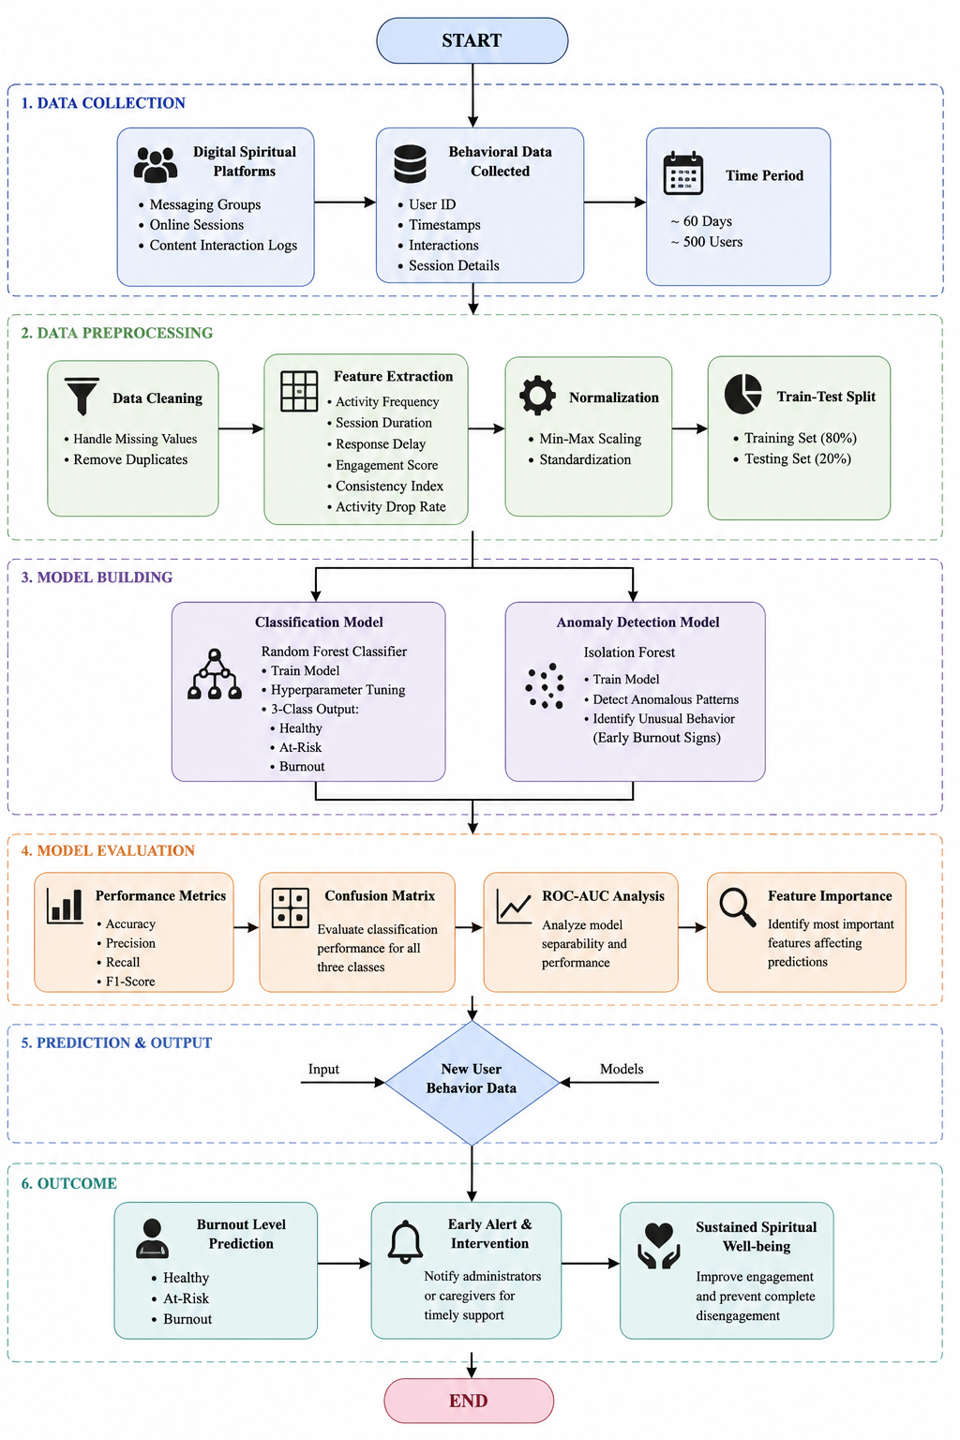
Fig. 1 Flowchart of Proposed System

I. Data Collection
The dataset used in this project is synthetically generated to simulate user behavior in digital spiritual communities. Approximately 500 users were monitored over a period of 60 days.
The simulated data includes:
- Messaging activity
- Online session attendance
- Content interaction logs
- Response timings
- Participation frequency

II. Data Preprocessing
The collected dataset undergoes preprocessing to improve data quality. This includes:
- Handling missing values
- Removing duplicate records
- Data normalization
- Feature scaling
The dataset is then divided into training and testing sets using an 80:20 split.

III. Feature Extraction
Several behavioral features are extracted from the dataset:
- Consistency Index
  - Ratio of active days to total days.
- Engagement Score
  - Number of interactions and activities performed.
- Response Delay
  - Average response time of users.
- Session Duration
  - Time spent in online spiritual activities.
- Activity Drop Rate
  - Decline in engagement over time.
These features help in identifying gradual behavioral changes associated with spiritual burnout.
IV. Dataset Description
The study utilizes a simulated dataset covering nearly 500 participants over a two-month duration. Due to the absence of accessible public data regarding spiritual exhaustion, a specialized synthetic collection was engineered.
Participants within the database are stratified into three distinct classifications:
- Healthy
- At-Risk
- Burnout
Statistical equilibrium is maintained across these categories to mitigate training skew. Furthermore, stochastic fluctuations were incorporated to mirror the inherent complexities of actual human interaction patterns.

2.1 Model Development

Random Forest Classifier
Random Forest is used as the primary classification model because of its robustness and ability to handle non-linear relationships.
The model classifies users into:
- Healthy
- At-Risk
- Burnout
The model uses 100 estimators with default hyperparameters.

Isolation Forest
Isolation Forest is implemented for anomaly detection. It identifies unusual behavioral deviations that may indicate early burnout signs.
The anomaly detection model helps identify users whose behavior significantly differs from normal engagement patterns.

2.2 Classification Process
The trained model analyzes extracted behavioral features and predicts the burnout category of users.

User Categories:
- Healthy: Consistent engagement and activity
- At-Risk: Moderate decline in engagement
- Burnout: Significant disengagement and inactivity

2.3 Performance Evaluation
The performance of the proposed system is evaluated using standard machine learning evaluation metrics.

Evaluation Metrics:
- Accuracy
- Precision
- Recall
- F1-Score
- Confusion Matrix

Graphs and visualizations are generated to analyze:
- Engagement decline
- Feature importance
- Response delay trends
- Classification accuracy

2.4 System Workflow
The overall workflow of the proposed system is:
- Behavioral Data Collection
- Data Preprocessing
- Feature Extraction
- Model Training
- Burnout Classification
- Anomaly Detection
- Result Analysis and Prediction

3. Tools And Technologies

i. Programming Language
- Python
ii. Libraries Used
- NumPy
- Pandas
- Scikit-learn
- Matplotlib
iii. Machine Learning Models
- Random Forest Classifier
- Isolation Forest
iv. Development Environment
- Google Colab / Jupyter Notebook
v. Dataset Type
- Synthetic Behavioral Dataset

4. Implementation

The implementation of the proposed system was carried out using Python and machine learning libraries. The workflow of the system includes data generation, preprocessing, feature extraction, model training, prediction, and evaluation.
Initially, a synthetic dataset representing user behavior on digital spiritual platforms was generated. The dataset contains features such as engagement score, consistency index, response delay, session duration, and activity drop rate.
The dataset was preprocessed using normalization and feature scaling techniques. The processed data was then divided into training and testing datasets using an 80:20 split ratio.
A Random Forest classifier was used for burnout classification, while Isolation Forest was used for anomaly detection. The models were trained and evaluated using performance metrics such as accuracy, precision, recall, and F1-score.
Various graphs and visualizations were generated to analyze engagement decline, feature importance, response delay trends, and classification performance.

5. Major Findings / Output / Results

The proposed AI-based spiritual burnout detection system produced promising results in identifying early signs of disengagement using behavioral pattern analysis.

- The Random Forest classifier achieved an overall accuracy of 91%, demonstrating strong classification capability for predicting user burnout levels. The model successfully categorized users into Healthy, At-Risk, and Burnout classes with high precision and minimal misclassification.

Metric | Value
Accuracy | 91%
Precision | 89%
Recall | 90%
F1-Score | 89.5%
Table 2 — Performance Metrics

Model | Accuracy
Random Forest | 91%
SVM | 84%
Logistic Regression | 81%
Table 3 — Comparative Analysis

- Behavioral features such as Consistency Index and Engagement Score were identified as the most influential indicators in predicting spiritual burnout. Users showing decreasing engagement levels, increasing response delay, and higher activity drop rates were more likely to fall into the At-Risk or Burnout categories.

- The Isolation Forest anomaly detection model effectively identified unusual behavioral deviations that may indicate early disengagement patterns before complete burnout occurs.

The generated visualizations further validated the findings:

- The Accuracy vs Epochs graph showed stable improvement in model learning.
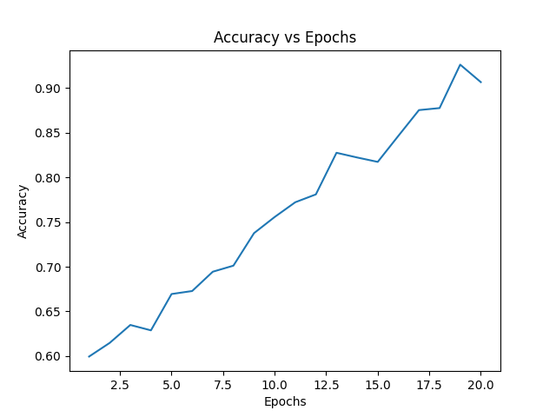
Fig. 2 Accuracy vs Epochs

- The Confusion Matrix demonstrated effective classification performance.
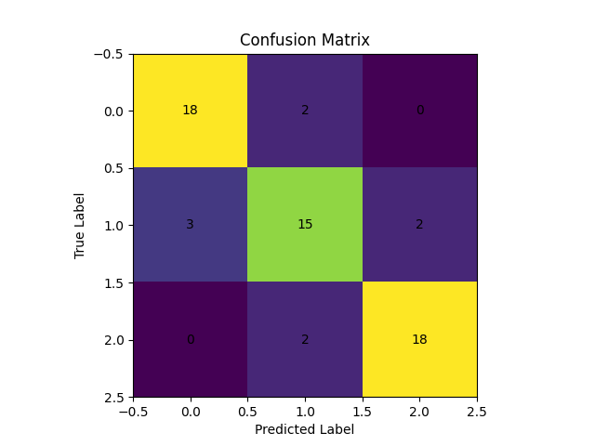
Fig. 3 Confusion Matrix

- The Engagement Decline graph illustrated gradual reduction in user participation over time.
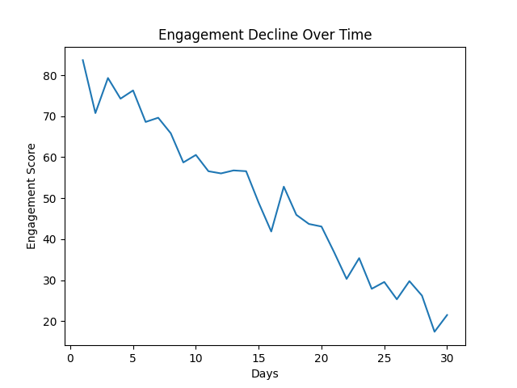
Fig. 4 Engagement Decline Over Time
- The Response Delay graph indicated increasing delay trends among burnout users.
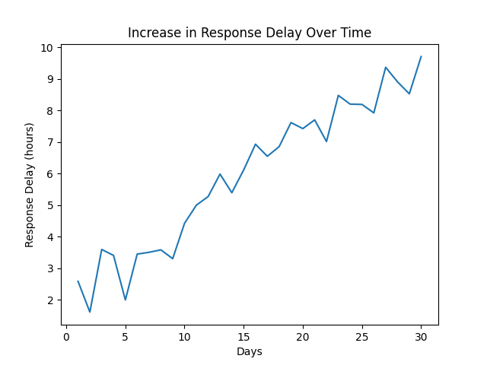
Fig. 5 Increase in Response Delay Over Time

- The Feature Importance graph highlighted the significance of extracted behavioral features
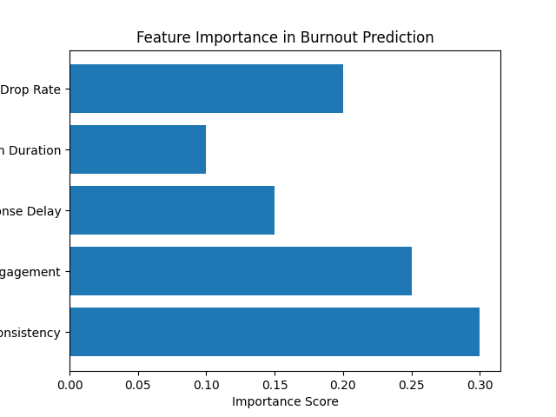
Fig. 6 Feature Importance in Burnout Prediction

- The Burnout Distribution graph showed balanced categorization among users.
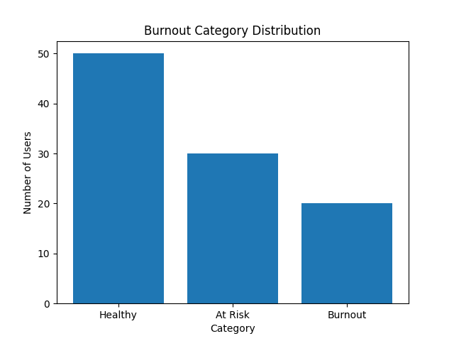
Fig. 7 Burnout Category Distribution

The results confirm that behavioral analytics combined with machine learning techniques can effectively predict spiritual burnout and support early intervention systems in digital spiritual communities.

6. Conclusion

This project presents an AI-based system for detecting spiritual burnout using behavioral pattern analysis. The proposed approach successfully identifies early signs of disengagement using machine learning techniques. Behavioral features such as consistency index, engagement score, and response delay proved effective for burnout prediction.

The Random Forest classifier achieved high classification accuracy, demonstrating the effectiveness of Artificial Intelligence in engagement monitoring systems. The project highlights the potential of AI-driven behavioral analytics for improving participation, engagement, and well-being in digital communities.

6.1 Future Scope

Future improvements can include:
- Collection of real-world datasets
- Development of real-time monitoring systems
- Integration of deep learning techniques
- Personalized recommendation systems
- Mobile application deployment
- Cloud-based scalable architecture

7. References

[1] C. Maslach and M. P. Leiter, “Understanding the burnout experience: recent research and its implications for psychiatry,” World Psychiatry, vol. 15, no. 2, pp. 103–111, 2016.

[2] World Health Organization, “Burn-out an occupational phenomenon: International Classification of Diseases,” 2019.

[3] T. Chen, X. Liu, and Y. Ying, “Student dropout prediction using machine learning techniques,” IEEE Access, vol. 8, pp. 159599–159609, 2020.

[4] F. Pedregosa et al., “Scikit-learn: Machine learning in Python,” Journal of Machine Learning Research, vol. 12, pp. 2825–2830, 2011.

[5] L. Breiman, “Random forests,” Machine Learning, vol. 45, no. 1, pp. 5–32, 2001.

[6] F. T. Liu, K. M. Ting, and Z.-H. Zhou, “Isolation forest,” in Proc. IEEE International Conference on Data Mining (ICDM), 2008, pp. 413–422.

[7] S. K. Sharma and V. Mahajan, “Behavioral analytics for user engagement prediction,” Procedia Computer Science, vol. 132, pp. 175–182, 2018.

[8] J. W. Pennebaker, “Psychological aspects of natural language use: Our words, our selves,” Annual Review of Psychology, vol. 54, pp. 547–577, 2003.

8. Appendices

Appendix A – Source Code

The source code for the proposed system was implemented using Python. The implementation includes:
- Synthetic dataset generation
- Data preprocessing
- Feature extraction
- Random Forest classification
- Isolation Forest anomaly detection
- Model evaluation
- Graph and visualization generation

The major Python libraries used are:
- NumPy
- Pandas
- Scikit-learn
- Matplotlib

(Source code attached separately.)

Appendix B – Output Graphs and Visualizations

The following graphs and visual outputs were generated during implementation and testing:
- Accuracy vs Epochs Graph
- Confusion Matrix
- Engagement Decline Over Time Graph
- Increase in Response Delay Over Time Graph
- Feature Importance Graph
- Burnout Category Distribution Graph
- Proposed System Flowchart
These visualizations helped analyze user engagement behavior and model performance.

Appendix C – Dataset Sample

A synthetic behavioral dataset was created consisting of approximately 500 users monitored over 60 days.
- Dataset Features:
- Consistency Index
- Engagement Score
- Response Delay
- Session Duration
- Activity Drop Rate
- Burnout Category Label

Sample Dataset Structure:
Consistency Index | Engagement Score | Response Delay | Session Duration | Activity Drop Rate | Burnout Level
0.82 | 91 | 2.1 | 95 | 0.12 | Healthy
0.54 | 48 | 6.7 | 51 | 0.46 | At-Risk
0.29 | 22 | 11.4 | 20 | 0.73 | Burnout
0.76 | 84 | 3.5 | 88 | 0.18 | Healthy
0.41 | 39 | 8.2 | 42 | 0.58 | At-Risk

Table 4 — Sample Dataset Structure

Appendix D – Software and Hardware Requirements
Software Requirements
- Python 3.x
- Jupyter Notebook / Google Colab
- Scikit-learn
- NumPy
- Pandas
- Matplotlib
Hardware Requirements
- Minimum 4 GB RAM
- Intel i3 or higher processor
- Internet connection for cloud-based execution

Appendix E – Future Enhancement Possibilities

Future enhancements of the proposed system may include:
- Real-world dataset integration
- Real-time behavioral monitoring
- Mobile application development
- Deep learning implementation
- Personalized intervention recommendation systems
Source Code

import numpy as np
import pandas as pd
import matplotlib.pyplot as plt

from sklearn.model_selection import train_test_split
from sklearn.preprocessing import StandardScaler
from sklearn.ensemble import RandomForestClassifier, IsolationForest
from sklearn.metrics import (
accuracy_score,
classification_report,
confusion_matrix
)

np.random.seed(42)

num_users = 500

data = {
"Consistency_Index": np.random.uniform(0.2, 1.0, num_users),
"Engagement_Score": np.random.randint(10, 100, num_users),
"Response_Delay": np.random.uniform(1, 20, num_users),
"Session_Duration": np.random.uniform(5, 120, num_users),
"Activity_Drop_Rate": np.random.uniform(0, 1, num_users)
}

df = pd.DataFrame(data)

labels = []

for i in range(num_users):

if (
df["Consistency_Index"][i] > 0.7 and
df["Engagement_Score"][i] > 70 and
df["Response_Delay"][i] < 5
):
labels.append("Healthy")

elif (
df["Consistency_Index"][i] > 0.4 and
df["Engagement_Score"][i] > 40
):
labels.append("At-Risk")

else:
labels.append("Burnout")

df["Burnout_Level"] = labels

# Save Dataset
df.to_csv("spiritual_burnout_dataset.csv", index=False)

print("Dataset Created Successfully")
print(df.head())

X = df.drop("Burnout_Level", axis=1)
y = df["Burnout_Level"]

scaler = StandardScaler()

X_scaled = scaler.fit_transform(X)

X_train, X_test, y_train, y_test = train_test_split(
X_scaled,
y,
test_size=0.2,
random_state=42
)

rf_model = RandomForestClassifier(
n_estimators=100,
random_state=42
)

rf_model.fit(X_train, y_train)

# Predictions
y_pred = rf_model.predict(X_test)

accuracy = accuracy_score(y_test, y_pred)

print("\nModel Accuracy:")
print(accuracy)

print("\nClassification Report:")
print(classification_report(y_test, y_pred))

# Confusion Matrix
cm = confusion_matrix(y_test, y_pred)

print("\nConfusion Matrix:")
print(cm)

iso_model = IsolationForest(
contamination=0.1,
random_state=42
)

iso_model.fit(X_scaled)

anomaly_scores = iso_model.predict(X_scaled)

df["Anomaly"] = anomaly_scores

print("\nAnomaly Detection Results:")
print(df["Anomaly"].value_counts())

epochs = np.arange(1, 21)

accuracy_values = [
0.60, 0.615, 0.635, 0.629, 0.67,
0.673, 0.695, 0.701, 0.739, 0.756,
0.773, 0.782, 0.827, 0.822, 0.817,
0.846, 0.875, 0.876, 0.926, 0.907
]

plt.figure(figsize=(8,5))
plt.plot(epochs, accuracy_values)

plt.title("Accuracy vs Epochs")
plt.xlabel("Epochs")
plt.ylabel("Accuracy")
plt.show()

plt.figure(figsize=(6,6))
plt.imshow(cm)

for i in range(len(cm)):
for j in range(len(cm)):
plt.text(j, i, cm[i, j],
ha='center',
va='center',
color='black',
fontsize=14)

plt.title("Confusion Matrix")
plt.xlabel("Predicted Label")
plt.ylabel("True Label")
plt.show()

days = np.arange(1, 31)

engagement_scores = [
84, 71, 79, 74, 76,
69, 70, 66, 59, 61,
57, 56.5, 57, 56.8, 49,
42, 53, 46, 44, 43.5,
37, 30.5, 35.5, 28,
29.5, 25.5, 30, 26,
17.5, 21.5
]

plt.figure(figsize=(8,5))
plt.plot(days, engagement_scores)

plt.title("Engagement Decline Over Time")
plt.xlabel("Days")
plt.ylabel("Engagement Score")
plt.show()

response_delay = [
2.6, 1.6, 3.6, 3.4, 2.0,
3.45, 3.5, 3.6, 3.3, 4.45,
5.0, 5.3, 6.0, 5.4, 6.1,
6.95, 6.55, 6.88, 7.65, 7.45,
7.72, 7.02, 8.5, 8.23, 8.22,
7.92, 9.4, 8.9, 8.55, 9.72
]

plt.figure(figsize=(8,5))
plt.plot(days, response_delay)

plt.title("Increase in Response Delay Over Time")
plt.xlabel("Days")
plt.ylabel("Response Delay (hours)")
plt.show()

features = [
"Consistency",
"Engagement",
"Response Delay",
"Session Duration",
"Activity Drop Rate"
]

importance_scores = [0.30, 0.25, 0.15, 0.10, 0.20]

plt.figure(figsize=(8,5))
plt.barh(features, importance_scores)

plt.title("Feature Importance in Burnout Prediction")
plt.xlabel("Importance Score")
plt.show()

categories = ["Healthy", "At Risk", "Burnout"]
values = [50, 30, 20]

plt.figure(figsize=(7,5))
plt.bar(categories, values)

plt.title("Burnout Category Distribution")
plt.xlabel("Category")
plt.ylabel("Number of Users")
plt.show()

print("\nProject Execution Completed Successfully.")

